**News**

**About**

**Products**

**Contact**

Drop Down Menu



**Home**

Home

About

|  |  |  |  |  |  |
| --- | --- | --- | --- | --- | --- |
| **Picture with Banner and slide minimum 5 Pictures**  Products   |  |  |  |  |  | | --- | --- | --- | --- | --- | | **Chickpeas Sel.jpg**  Contact  News | **Yellow Muster Seeds sel.jpg** | **Cumin Seeds.jpg** | **wheat Sel.jpg** | **Chemical**  **Bitumen Sel.jpg** | |

**M/S. Noor Corporation**

##### We are Messrs. Noor Corporation, A Reputed Indenting Agent in Bangladesh.

##### M/S. Noor Corporation is an established indenting agent (broker house). Since 2005, we have been providing contract products to any buyer in Khatungonj and all over the Bangladesh with good reputation. We have skilled manpower to serve you. Those are constantly working to deliver products on time.

|  |  |  |
| --- | --- | --- |
| ADDRESS 189, Elias Market (2nd Floor), Khatunganj, Chattogram, Bangladsesh. | PHONE NUMBER Office +880 233 336 6576  +880 1817 713 543  +880 1977 113 543 | EMAIL [info@noorcorporationbd.com](mailto:info@example.com)  Top of Form  Bottom of Form |

### © Copyright M/S. Noor Corporation. All Rights Reserved.

Top of Form

Bottom of Form

­­

**Products**

**News**

**Contact**



**Home**

**About Us**

|  |
| --- |
| 1 Picture as like Banner style  Overview.jpg |

We are commitment to our buyer and constantly working supply best agro product for them. Reliability has been one of the key drivers of our growth. It is our principle that timely execution of contracts and delivering our commitments to the satisfaction of both suppliers and buyers. For commitment to country trying to build a nourished the nation.

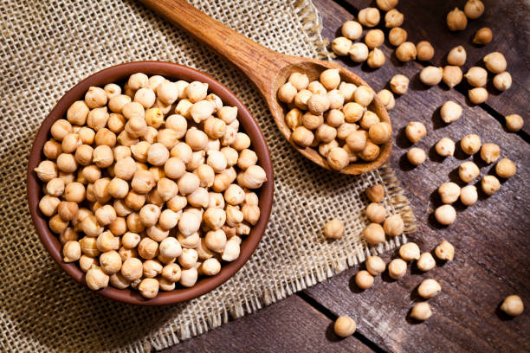

### © Copyright M/S. Noor Corporation. All Rights Reserved.

**Contact**



**Home**

**About**

**Products**

**News**

|  |  |  |  |  |  |
| --- | --- | --- | --- | --- | --- |
| 5 Picture with banner and slide animation and hyperlink each picture item  Pulses  Oil Seeds  Grain  Spices  Chemical   |  |  |  |  |  | | --- | --- | --- | --- | --- | | Black Matpe Sel.jpg | Canola Sel.jpg | Rice Sel.jpg | Termeric 1 sel.jpg | Bitumen Sel.jpg | |

1. Pulses

|  |  |
| --- | --- |
| Chickpeas  Chickpeas Sel.jpg | Chickpeas- Kabra, Jimbour etc. We are selling from Australia, Myanmar and Ethiopia. |

|  |  |
| --- | --- |
| Nipper Lentils  Nipper sel.jpg | Nipper Lentils- We are selling from Australia. Australian Nippers. |

|  |  |  |  |
| --- | --- | --- | --- |
| Nugget and Flash   |  |  | | --- | --- | | Nugget.jpg | Flash Lentils.jpg | | Nugget and Flash – We are selling from Australia. |

|  |  |
| --- | --- |
| Crimson  Crimson.jpg | Crimson – We are selling from Canada. |

|  |  |
| --- | --- |
| Yellow Peas  Yellow peas sel.jpg | Yellow Peas- We are selling from Canada, Ukraine, Russia, Romania, Bulgaria. |

|  |  |
| --- | --- |
| Dun Peas  Dun Peas Sel.jpg | Dun Peas – We are selling from Australia. |

|  |  |
| --- | --- |
| Black Matpe  Black Matpe Sel.jpg | Black Matpe- We are selling from Myanmar. |

|  |  |
| --- | --- |
| Green Mung Bean  Green Mung sel.jpg | Green Mung Bean- We are selling from Myanmar, Tanzania, Uganda, Argentina . |

1. Oil Seeds

|  |  |
| --- | --- |
| Yellow Mustard Seeds  Yellow Muster Seeds sel.jpg | Yellow Mustard Seeds- We are selling from Russia. |

|  |  |
| --- | --- |
| Rapeseeds  Rape seed.jpg | Rapeseeds- We are selling from Ukraine, Moldova. |

|  |  |
| --- | --- |
| Canola  Canola Sel.jpg | Canola- We are selling from Australia, Canada. |

|  |  |
| --- | --- |
| Soybean  Soyabean Sel.jpg | Soybean- We are selling from Malaysia. |

1. Grain

|  |  |
| --- | --- |
| Wheat  wheat Sel.jpg | Wheat- We are selling Australia, Ukraine, Russia, Canada. (Protein: 10, 11, 11.5, 12, and 12.5) |

|  |  |
| --- | --- |
| Rice  Rice Sel.jpg | Rice- Non Basmati - We are selling from India, Pakistan, Thailand and Myanmar. |

|  |  |
| --- | --- |
| Maize  Maize Sel.jpg | Maize- We are selling from India, Brazil and Argentina. |

1. Spices

|  |  |
| --- | --- |
| Garlic  Garlic Sel.jpg | Garlic-We are selling from China. |

|  |  |
| --- | --- |
| Ginger  Ginger sel.jpg | Ginger- We are selling from China. |

|  |  |
| --- | --- |
| Cumin Seeds  Cumin Seeds.jpg | Cumin Seeds-We are selling from India, Iran, Afghanistan and Turkey. |

|  |  |  |  |
| --- | --- | --- | --- |
| Turmeric   |  |  | | --- | --- | | Termeric 1 sel.jpg | Termeric 2 sel.jpg | | Turmeric-We are selling from India and Myanmar. |

1. Chemical

|  |  |
| --- | --- |
| Bitumen  Bitumen Sel.jpg | Bitumen – We are selling from Iran, Dubai, Saudi Arab. |

### © Copyright M/S. Noor Corporation. All Rights Reserved.



**Contact**

**Home**

**About**

**Products**

**News**

|  |
| --- |
| Picture of office with banner and slide animation  Office main.jpg |

|  |  |  |  |
| --- | --- | --- | --- |
| Personal Pic |  |  |  |
|  |  |  |  |
|  |  |  |  |

### © Copyright M/S. Noor Corporation. All Rights Reserved.



**About**

**Products**

**News**

**Contact**

**Home**

|  |
| --- |
| 1 Picture contact with banner and slide animation  contact pic.jpg |

|  |  |  |
| --- | --- | --- |
| ADDRESS 189, Elias Market (2nd Floor), Khatunganj, Chattogram, Bangladsesh. | PHONE NUMBER Office +880 233 336 6576  +880 1817 713 543  +880 1977 113 543 | EMAIL [info@noorcorporationbd.com](mailto:info@example.com)  Top of Form  Bottom of Form |

### © Copyright M/S. Noor Corporation. All Rights Reserved.